**The University Of Azad Jammu & Kashmir,**

**Muzaffarabad**

**Department of Software Engineering**

**LAB TASK 10**

**Database Systems**

**Course Code**: **CS-2204**

**Submitted To:**

Engr. Tahir Jahangir

**Submitted By:**

Ahmed Ali

**Roll No:**

2023-SE-41

**Session**: 2023-2027

Contents

Lab Task – 9: Entity Relationship Diagram (ERD) – Part I 4

🎯 Objective: 4

📘 Task 01: Domain Exploration and Entity Extraction 4

Scenario: 4

Instructions: 4

**Notes:** 5

📘 Task 02: Attribute Modeling and Visual Sketch 5

Instructions: 5

1. Classify each attribute as simple, composite, derived, or multivalued. 5

1. Attribute Classification 6

📘 Task 03: Entity vs Attribute Decision-Making Task 7

Instructions: 7

Items: 7

Part A: 7

Part B: 7

📘 Task 04: Guided ERD Design Without Relationships 8

Scenario: 8

Instructions: 8

2. Use correct ER notations. 8

3. Clearly underline primary keys. 8

📘 Task 05: Scenario-Based ERD Construction (Independent) 9

Scenario: 9

Instructions: 9

2. Include all attributes and underline primary keys. 9

4. Do not include relationships yet (covered in Lab 10). 9

# Lab Task – 9: Entity Relationship Diagram (ERD) – Part I

# 🎯 Objective:

Learn to analyze real-world domains, extract entities and attributes, classify them appropriately, and create basic ER diagrams. This lab builds foundational skills for ERD modeling before introducing relationships in the next session.

# 📘 Task 01: Domain Exploration and Entity Extraction

🎯 **Objective:** Practice identifying entities and their core data components from a real-world domain.

## Scenario:

A university hosts various student clubs. Each club has a name, type (e.g., Sports, Academic), and a faculty advisor. Students can join multiple clubs. For each student, the system stores student ID, name, email, and program.

## Instructions:

1. List all potential **entities**.
2. Identify **attributes** for each entity.
3. Suggest a **primary key** for each entity.
4. Classify each entity as **strong** or **weak** with justification.

📝 Submit in table format.

| **Entity** | **Attributes** | **Primary Key (PK)** | **Strong/Weak** | **Justification** |
| --- | --- | --- | --- | --- |
| **Student** | StudentID, Name, Email, Program | StudentID | Strong | Student can exist independently in the system without relying on another entity. |
| **Club** | ClubID, ClubName, Type (Sports/Academic/etc.), FacultyAdvisor | ClubID | Strong | Club exists independently and has its own identity. |
| **Faculty Advisor** | FacultyID, Name, Email, Department | FacultyID | Strong | A faculty advisor is an independent entity and can exist without being linked to a specific club. |
| **Membership** | MembershipID, StudentID (FK), ClubID (FK), JoinDate (optional) | MembershipID | Weak | Membership depends on both **Student** and **Club** for existence (association entity). |

### **Notes:**

* **Student** and **Club** are **core strong entities**.
* **Faculty Advisor** is also a strong entity because a faculty member exists independently of clubs.
* **Membership** is a **weak entity** (association entity) since it only makes sense in the context of linking students to clubs.

# 📘 Task 02: Attribute Modeling and Visual Sketch

🎯 **Objective:** Practice modeling and visually representing different attribute types in ERD.

## Instructions:

Using the entities from Task 1:

## Classify each attribute as simple, composite, derived, or multivalued.

### 1. Attribute Classification

| **Entity** | **Attributes** | **Attribute Type** |
| --- | --- | --- |
| **Student** | **StudentID** (PK), Name, Email, Program | StudentID → Simple, Name → Composite (FirstName, LastName), Email → Simple, Program → Simple |
| **Club** | **ClubID** (PK), ClubName, Type, FacultyAdvisor | ClubID → Simple, ClubName → Simple, Type → Simple, FacultyAdvisor → Composite (Name, Email) |
| **Faculty Advisor** | **FacultyID** (PK), Name, Email, Department | FacultyID → Simple, Name → Composite, Email → Simple, Department → Simple |
| **Membership** | **MembershipID** (PK), StudentID (FK), ClubID (FK), JoinDate | MembershipID → Simple, StudentID → Simple (FK), ClubID → Simple (FK), JoinDate → Derived (can be derived from system log) |

2. Sketch a **mini-ERD** for each entity: o Use correct symbols (ovals for attributes, underline for PK, etc.) o Represent composite/multivalued attributes with appropriate notation.

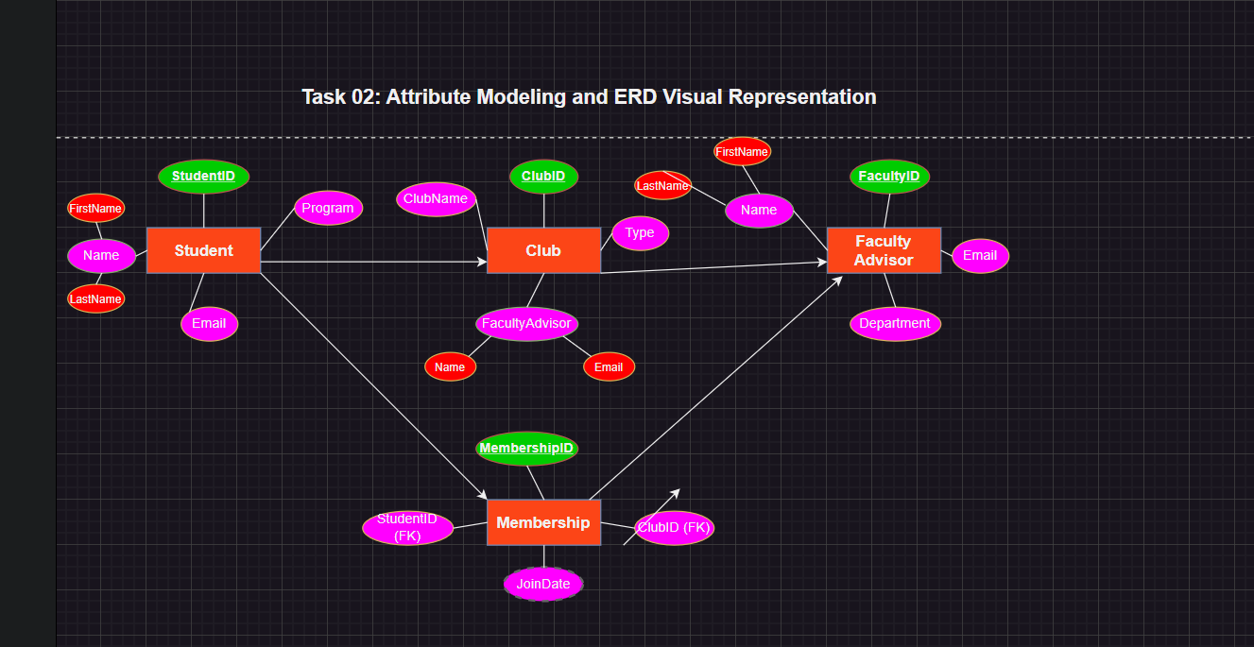

# 📘 Task 03: Entity vs Attribute Decision-Making Task

🎯 **Objective:** Practice distinguishing between entities and attributes.

## Instructions:

Analyze the following data items from a **conference management system**:

## Items:

Conference, Location, Start Date, Speaker, Session, Session Duration, Attendee, Attendee Name, Registration, Fee Paid

## Part A:

Classify each item as **Entity** or **Attribute**, with justification.

| **Item** | **Entity / Attribute** | **Justification** |
| --- | --- | --- |
| **Conference** | Entity | A core independent concept; multiple conferences can exist, each with unique details. |
| **Location** | Attribute / Could be Entity | If only the venue name/address is stored, it’s an attribute of Conference. If detailed info (city, building, rooms) is needed, then it should be modeled as a separate entity. |
| **Start Date** | Attribute | A property of a Conference. |
| **Speaker** | Entity | Speakers are independent actors (can speak at multiple sessions), so they need their own identity. |
| **Session** | Entity | Each conference consists of multiple sessions; sessions exist independently of other attributes. |
| **Session Duration** | Attribute | A descriptive property of a Session. |
| **Attendee** | Entity | Attendees are people with unique identities; they participate across sessions/conferences. |
| **Attendee Name** | Attribute | A descriptive detail of Attendee. |
| **Registration** | Entity | Represents the participation link between Attendee and Conference (association entity). |
| **Fee Paid** | Attribute | A property of Registration (amount paid for participation). |

## Part B:

Suggest **any missing entities or attributes** that should be modeled (e.g., "delivers", "registers for").

| **Missing Concept** | **Entity/Attribute** | **Justification** |
| --- | --- | --- |
| **Topic** | Attribute (of Session) | Describes what the session is about. |
| **Paper/Presentation** | Entity | In many conferences, sessions include papers or presentations — needs tracking separately. |
| **Schedule** | Attribute (of Session) | Defines session date/time within the conference. |
| **Delivers** | Relationship | Between **Speaker** and **Session** (Speaker delivers Session). |
| **Registers For** | Relationship | Between **Attendee** and **Conference** (Attendee registers for Conference). |
| **Attends** | Relationship | Between **Attendee** and **Session** (attendees may attend multiple sessions). |

# 📘 Task 04: Guided ERD Design Without Relationships

🎯 **Objective:** Design a partial ERD with attributes for each entity.

## Scenario:

A university maintains data about departments and faculty.

|  |  |
| --- | --- |
| **Entity** | **Attributes** |
| Department | Department_Code (PK), Department_Name, Building |
| Faculty | Faculty_ID (PK), Name, Designation, Email |

## Instructions:

1. Draw 2 entities with all attributes.

## 2. Use correct ER notations.

## 3. Clearly underline primary keys.

4. Use **draw.io or ERDPlus** to draw your diagram.

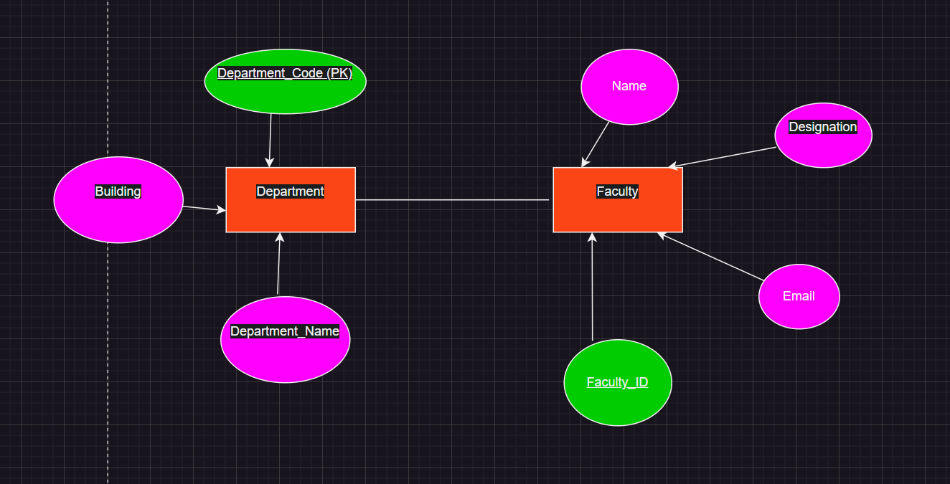

# 📘 Task 05: Scenario-Based ERD Construction (Independent)

🎯 **Objective:** Apply ER modeling concepts in a real-world scenario.

## Scenario:

A public library keeps records of books, members, and librarians.

|  |  |
| --- | --- |
| **Entity** | **Attributes** |
| Book | ISBN (PK), Title, Author, Category |
| Member | Member_ID (PK), Name, Address, Phone |
| Librarian | Emp_ID (PK), Name, Shift, Section |

## Instructions:

1. Create an ERD with all 3 entities.

## 2. Include all attributes and underline primary keys.

3. Use an ER diagramming tool.

## 4. Do not include relationships yet (covered in Lab 10).

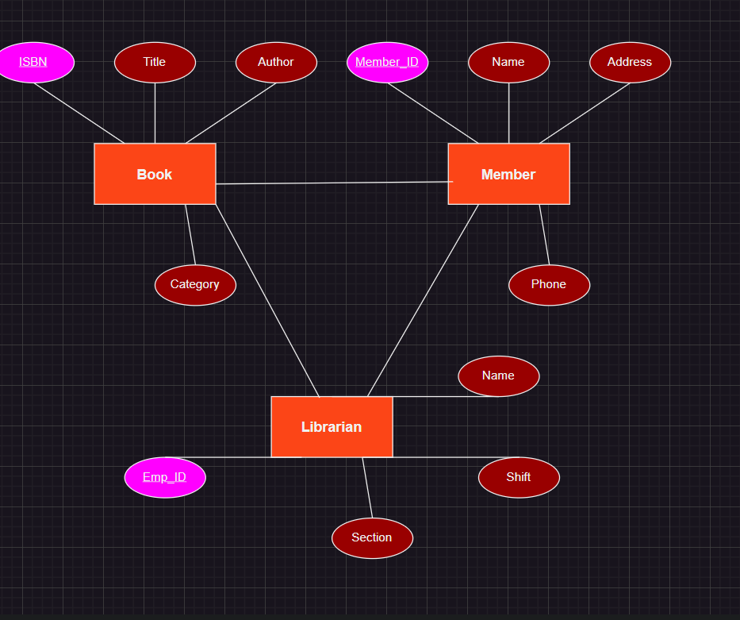

**Reflection:**

In this task, I learned how to design an ERD by identifying entities and their attributes. I also practiced marking primary keys with proper notation and organizing the diagram in draw.io. In starting it seems difficult .However, after some trial and error, I gained a clearer understanding of how to structure entities and attributes in ERD tools.